

Shri Shamrao Patil (Yadravkar) Educational & Charitable Trust’s

**Sharad Institute of Technology College of Engineering, Yadrav (Ichalkaranji)**

(An Autonomous Institute)

**Department of Artificial Intelligence & Data Science**

**A**

**Mini Project Synopsis**

**On**

**“EXPLORE KOLHAPUR”**

**Submitted by**

|  |  |  |
| --- | --- | --- |
| **Name of Student** | **Roll. No.** | **PRN No.** |
| Mr. Kagade Prajwal Arjun | T39 | 2210101019 |
| Mr. Kamble Prashil Prakash | T40 | 2210101020 |
| Mr. Khade Abhishek Bharat | T41 | 2210101021 |
| Mr. Shinde Chetan Sudhir | T64 | 2220101052 |

**Under the Guidance Of**

**Mrs. P.D. Nasalapure**

2024-25

**Guide HOD Principal**

(Mrs.P.D. Nasalapure) (Dr.A.J.Chinchawade) (Mr. S.A. Khot)

|  |  |
| --- | --- |
|  | Shri Shamrao Patil (Yadravkar) Educational & Charitable Trust’s  **Sharad Institute of Technology College of Engineering**  **Yadrav (Ichalkaranji) - 416121**  **An Autonomous Institute**  **(Approved by AICTE, New Delhi, Recognized by Government of Maharashtra & Affiliated to Dr. Babasaheb Ambedkar Technological University)**  **DEPARTMENT OF** **ARTIFICIAL INTELLIGENCE AND DATA SCIENCE** |

This is to certify that,

Mr. Kagade Prajwal Arjun. (39)

Mr. Kamble Prashil Prakash. (40)

Mr. Khade Abhishek Bharat. (41)

Mr. Shinde Chetan Sudhir. (64)

Studying in TY artificial has successfully completed the Mini Project entitled **“EXPLORE KOLHAPUR”** under the guidance and supervision of Mrs. P.D. Nasalapure. during the academic year 2024-2025 Semester V. This is a part of partial fulfillment of the requirement for award of degree of the Bachelor of Technology in Artificial Intelligence and Data Science.

**Mrs. P.D. Nasalapure**  **Dr. A.J Chinchawade**

Guide Associate Professor and Head

Dept. of Artificial Intelligence and Dept. of Artificial Intelligence and

Data Science Data Science

SITCOE SI TCOE

**Dr. S. A. Khot**

Principal

SITCOE

**ACKNOWLEDGEMENT**

We would like to express our deep and sincere gratitude to our Guide **Mrs. P.D. Nasalapure**

Department of Artificial Intelligence and Data Science, for guiding us to accomplish this project work. It was our privilege and pleasure to work under her valuable guidance. We are indeed grateful to her for providing helpful suggestion, from time to time. Due to her constant encouragement and inspiration, we are able to present this project.

We express our deep gratitude to **Dr. A.J Chinchawade,** Head of Artificial Intelligence and Data Science Department, for his valuable guidance and constant encouragement.

We are very much thankful to **Dr. S. A. Khot**, Principal, Sharad Institute of Technology College of Engineering, Yadrav-Ichalkaranji, for providing all the necessary facilities to carry out project work.

Last but not least we are thankful to our parents for their moral as well as financial support.

**Abstract**

There are so many travelling websites but, in that website, only some information about destination is provided, for example: they provide destination photos, some information related to that destination, history of that place etc. It is not efficient for the traveler or the user because if the user wants to find nearby places to visit, nearby residentials, nearby restaurant’s, map of that place etc. they should need to search separately, so we think that if we provide these all kind of information in a single website it could be more efficient for user to find and plan the proper trek.

**INDEX**

|  |  |  |
| --- | --- | --- |
| Sr.No | Title | Pages |
| 1) | Introduction | 4 |
| 2) | Problem Statement | 5 |
| 3) | Literature Review | 6-7 |
| 4) | Results | 8-11 |
| 5) | Future Scope | 12 |
| 6) | Objectives | 13 |
| 7) | Working and Methodology | 14-16 |
| 8) | System Requirements | 17 |
| 9) | Conclusion | 18 |
| 10) | References | 19 |

**Introduction**

Rationally the peoples don’t know the proper information about the destination, how to visit that place, Is there any facilities available or which places are surrounded by the destination they must know but they don’t get the proper source to get information. To overcome these problems, we have created the website “EXPLORE KOLHAPUR”. By using our website, they will get proper guide and proper information about the destination or places. In the dynamic landscape of many travelling websites, our mini-project seeks to address a pressing question: user/traveller not getting a proper information and guide for travelling at one place. This mini-project aims to provide a proper and reliable information, for finding best way for visiting destination, best and low-cost hotels and residentials near destination.

**Problem Statement**

In today's fast-paced world, travelers, tourists, and locals alike face the challenge of finding accurate, up-to-date, and reliable information about destinations, places of interest, and services at their fingertips.

**Literature Review**

**1)** **Travel Recommender Systems (TRS) and Visualization Tools for Tour Planning: -**

Author [Jayden Kimber](https://link.springer.com/chapter/10.1007/3-211-32710-X_9#auth-Jayden-Kimber),  [Mladen Georgievski](https://link.springer.com/chapter/10.1007/3-211-32710-X_9#auth-Mladen-Georgievski) & [Nalin Sharda](https://link.springer.com/chapter/10.1007/3-211-32710-X_9#auth-Nalin-Sharda)(2006) has published “Developing a Visualization Tool for Tour Planning” this research paper. The work in this in this research paper is focusing on the Travel Recommender Systems (TRS) are increasingly becoming popular to support the tourism industry. A TRS allows tourists to get an informed recommendation for travel planning via an artificial intelligence-based engine. Current TRSs do not provide tourists with the facility to visualize their complete holiday itinerary; i.e. location, transportation, accommodation, attractions and entertainment etc. The tourist has to browse through individual web pages to build a mental picture of the planned tour. Our aim is to develop a system that would allow the tourists to visualize their plan within the TRS to enhance their tour planning experience.

**2)** **Summarizing Urban Tourism Information from Massive Blog Data: -**

Author Pan, Maclaurin, & Crotts (2007) has published research paper “Summarizing urban tourism information from massive blog data”. In this work, we propose a research framework to help people summarize tourism information, such as popular tourist locations as well as their travel sequences (routes), for a previously unknown city from massive travel blog with the objective of providing users with better travel scheduling. To do this, we first crawl the massive travel blogs for a targeted city online. Then, we transfer the textual contents of these blogs to a series of word vectors to form the initial data source. Next, we implement the frequent pattern mining method on the data to identify the city's popular locations by their sequenced co-occurrences among the usual tourism activities, which can be visualized into a word network.

**3)Tourism Blog Visualizer for Better Tour Planning: -**

Author [Nalin Sharda](https://journals.sagepub.com/doi/abs/10.1177/1356766707087523#con1) and [Mohan Ponnada](https://journals.sagepub.com/doi/abs/10.1177/1356766707087523#con2)(2008) has published “Tourism Blog Visualizer for better tour planning” research paper. The work in this research paper is focusing on the rationale for building a Blog Visualizer, and elaborates on its conceptual model. Blog Visualizer is a system that uses the information present in blogs, such as images, video, and audio, to create an audio-visual interactive presentation for the user.The Blog Visualizer will provide potential tourists with virtual experience of the trip to support better tour planning.

**4)** Abstract Having the right image as a tourist destination brings immense benefits for a city’s international recognition in an increasingly competitive tourist industry. Official tourism websites as effective platforms to project a destination image online are able to provide substantial information about the tourist destination and attract a wider potential for inbound tourists from a global market. However, a lack of sufficient research has been noted regarding the integration of tourism studies and the study of website discourse, particularly visual discourse. This study, drawing on the theory of meta functions in semiotics, conducts a visual discourse analysis by examining the three meta functional meanings of visual images extracted from the official Beijing Tourism website. The results of both quantitative and qualitative analyses showed that the investigated website constructs an online city destination image through a multiplicity of tourist resources. The study concludes by outlining the practical benefits for tourism website designers and implications for future research.

**Results**

1)Introduction to Home Page: -

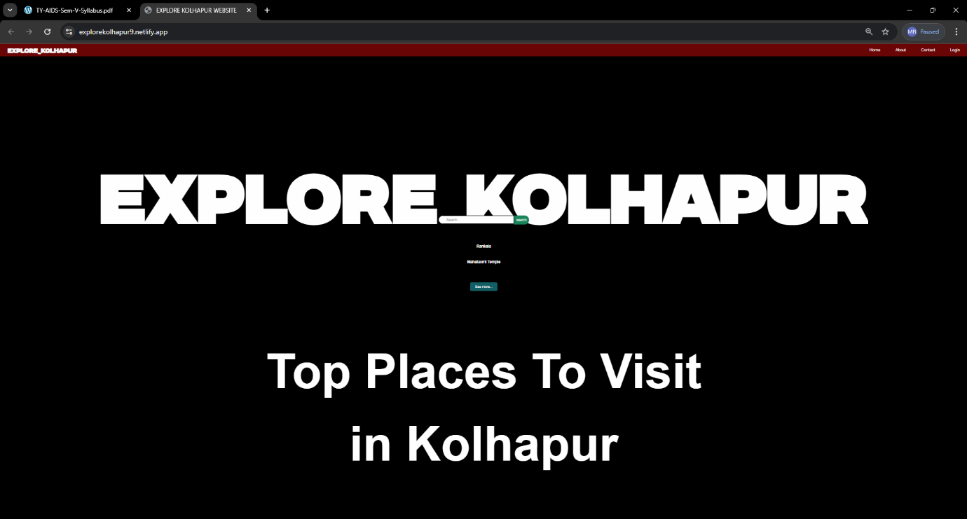

**FIG: - 1**

2)About Us: -

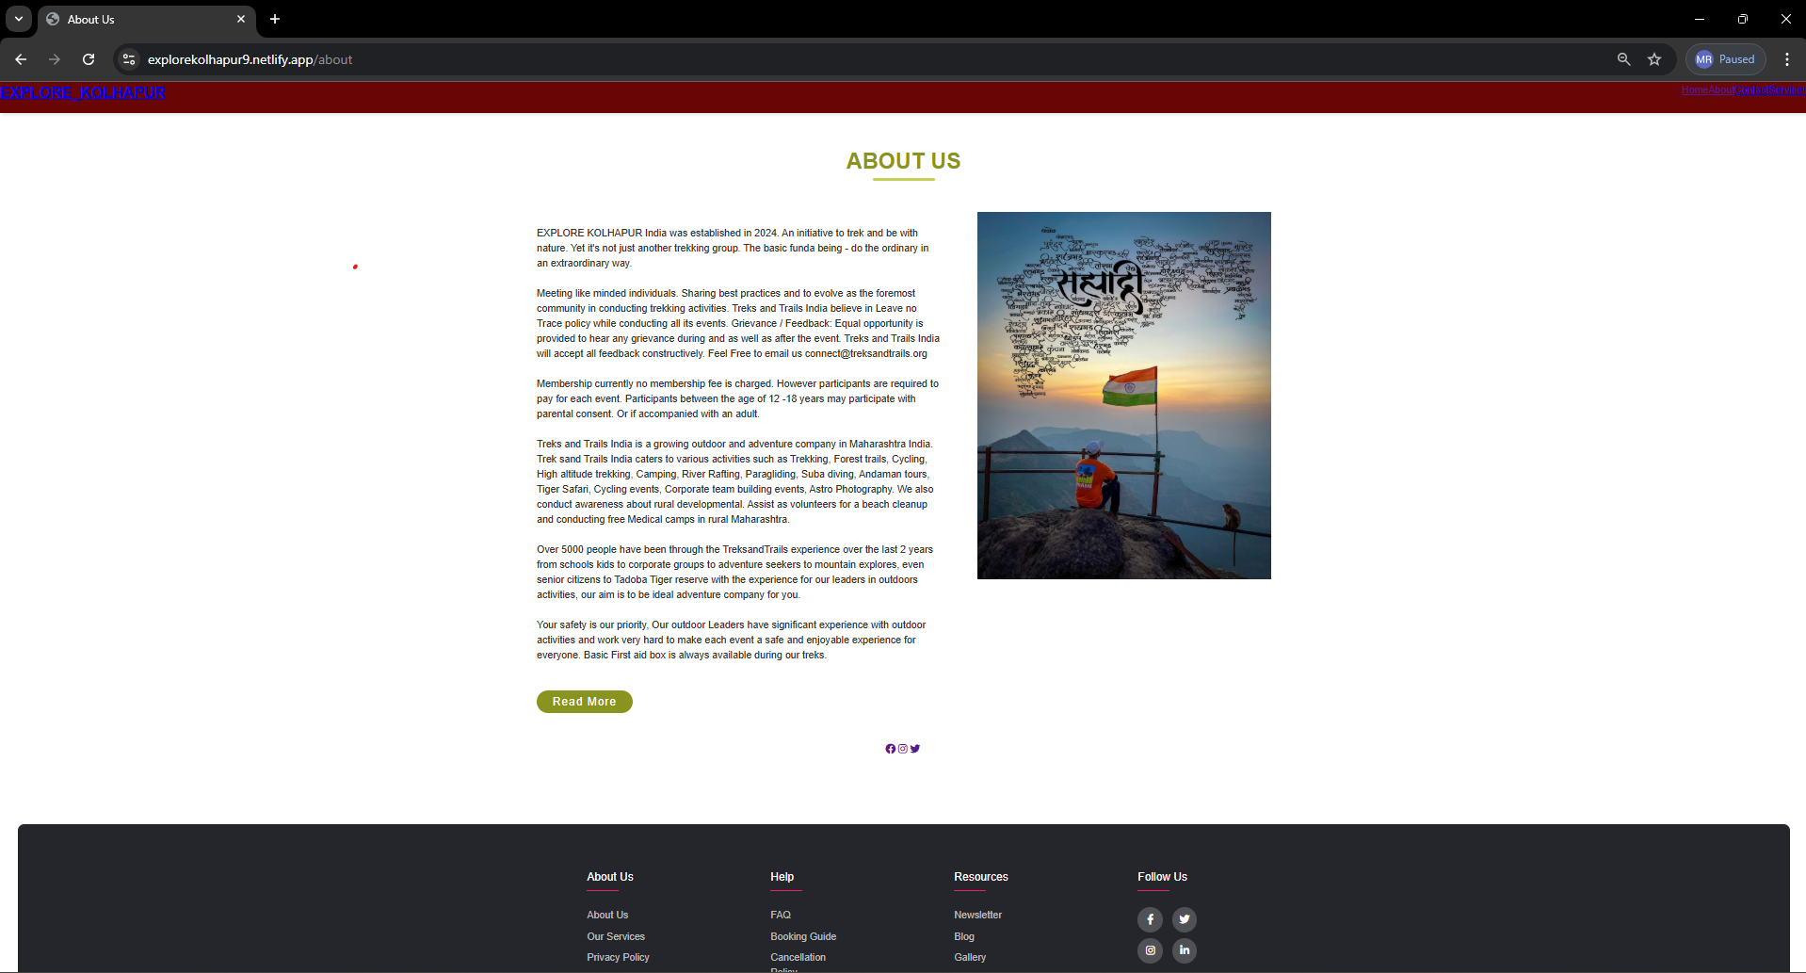

**FIG:-2**

3)Contant Us:-

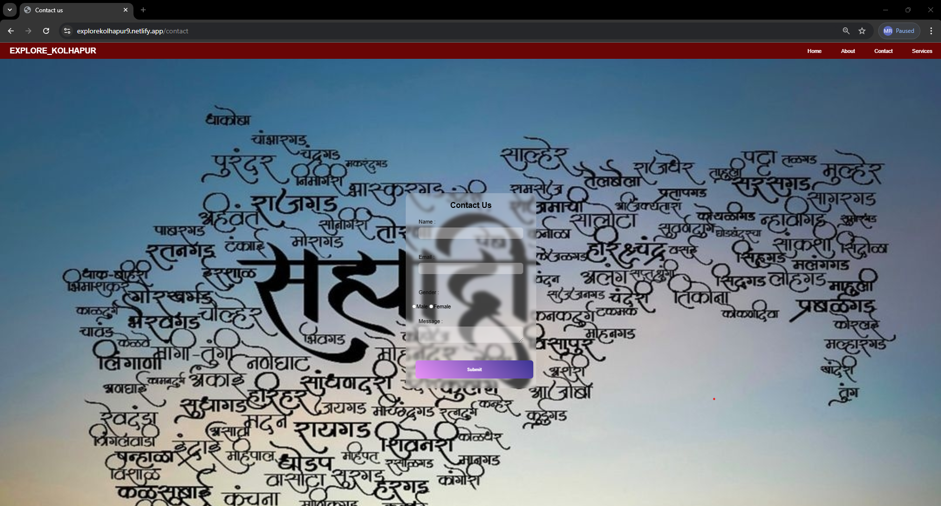

**FIG: -3**

4) Login Page:-

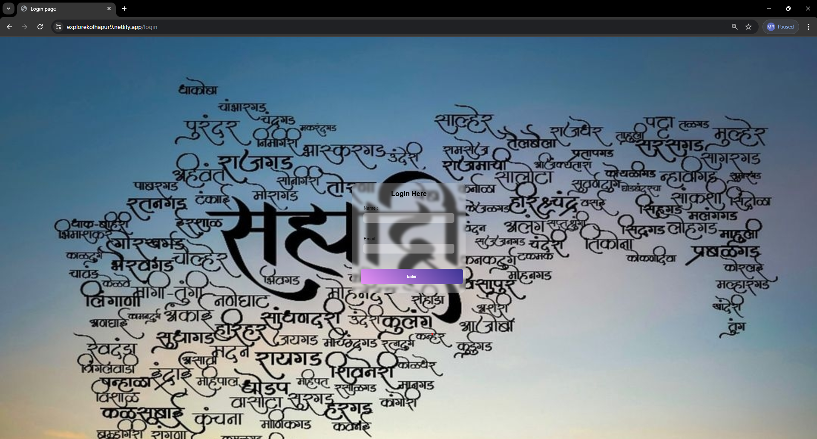

**FIG: - 4**

5)Popular Places Pages:-

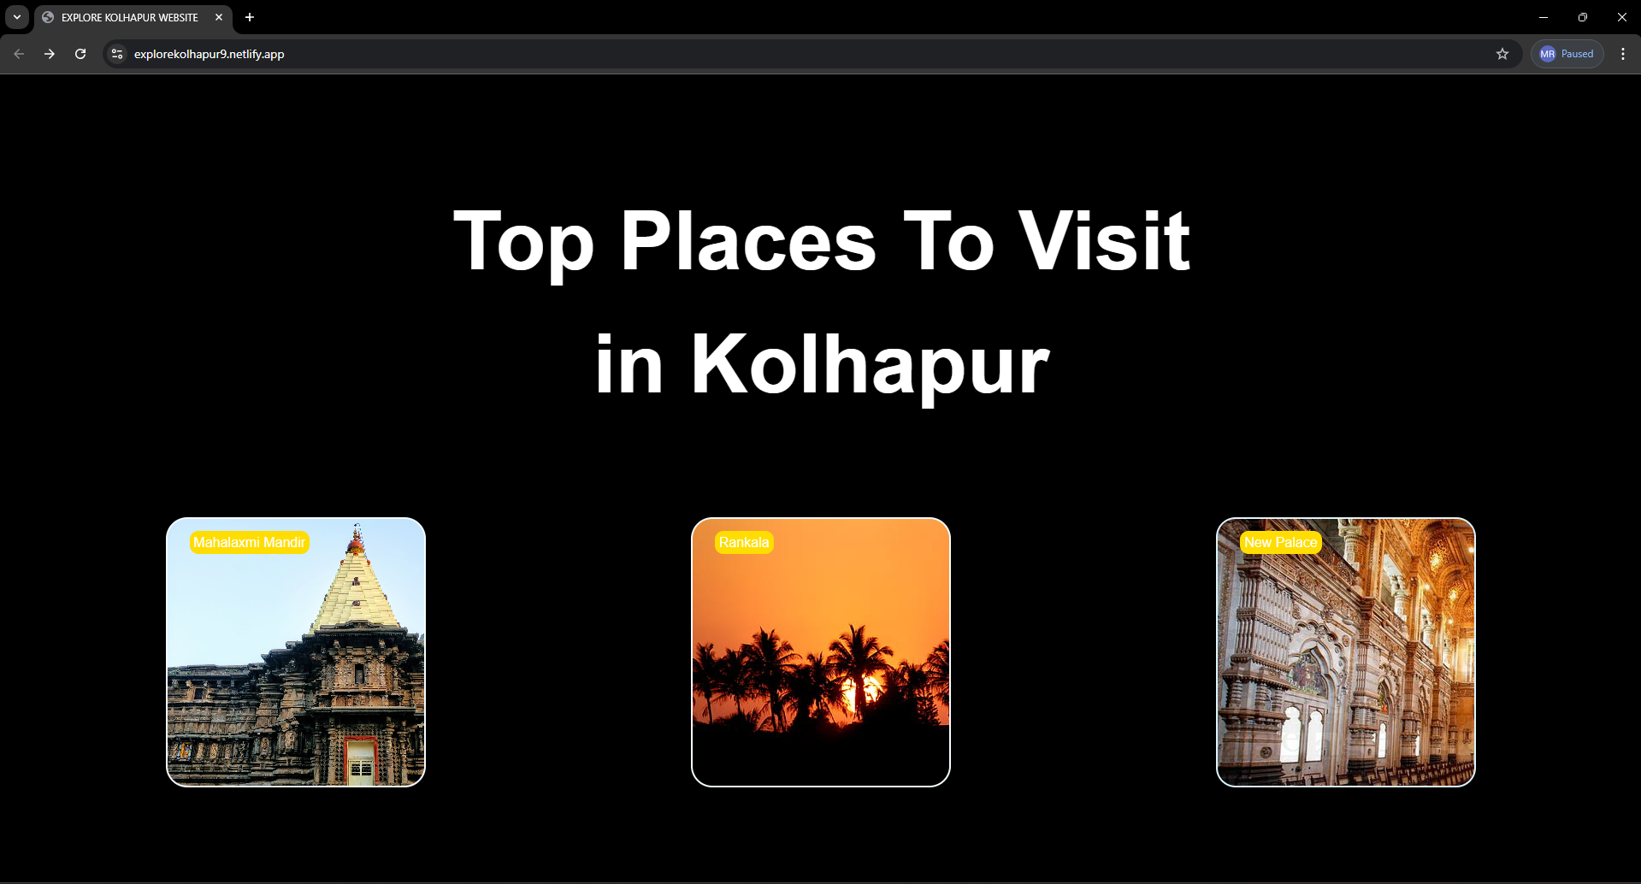

**FIG: -5**

6) Inforamtion Page of Rankala:-

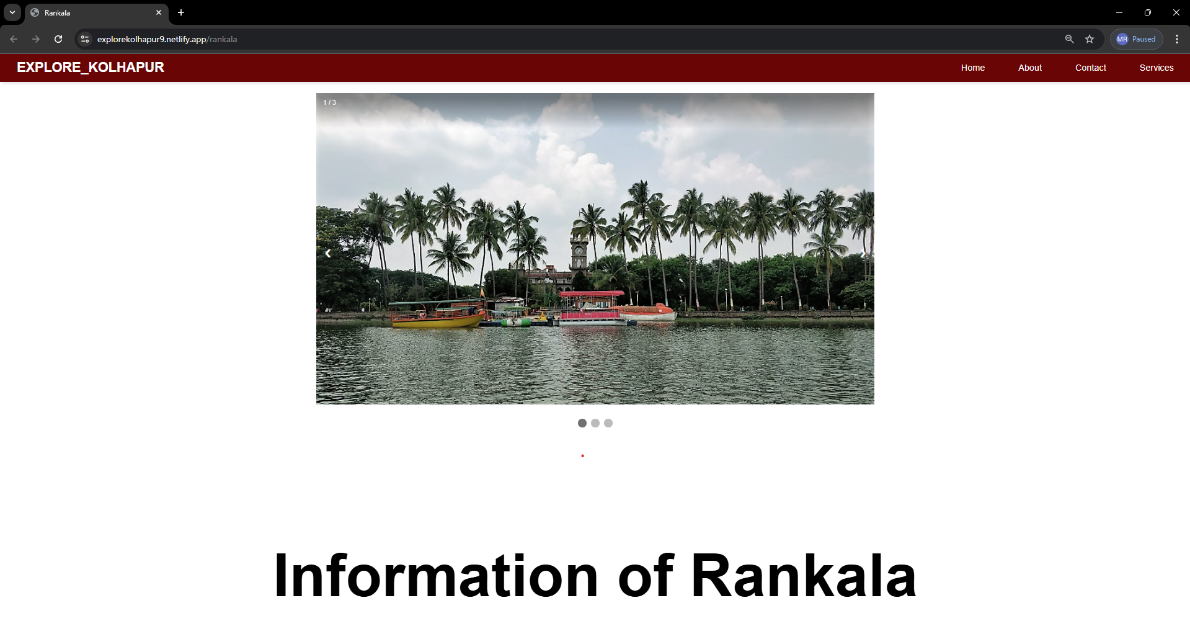

**FIG: -6**

7) Information Page of Mahalaxmi temple:-

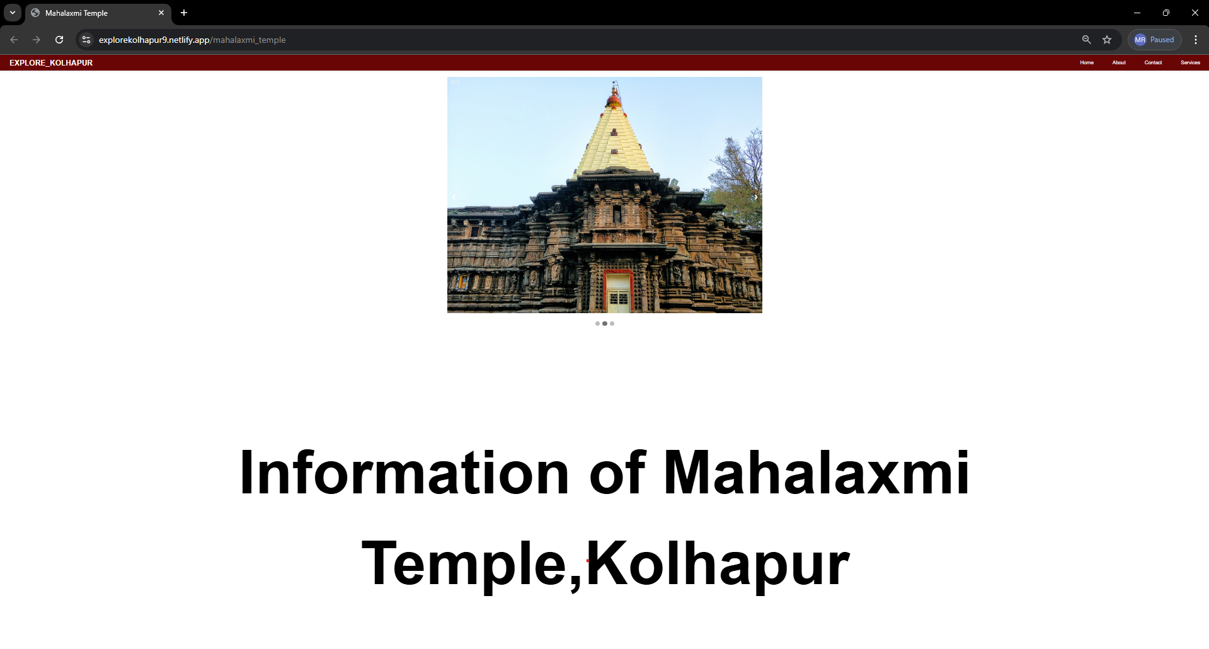

**FIG: -7**

8) Information Page of New Palace: -

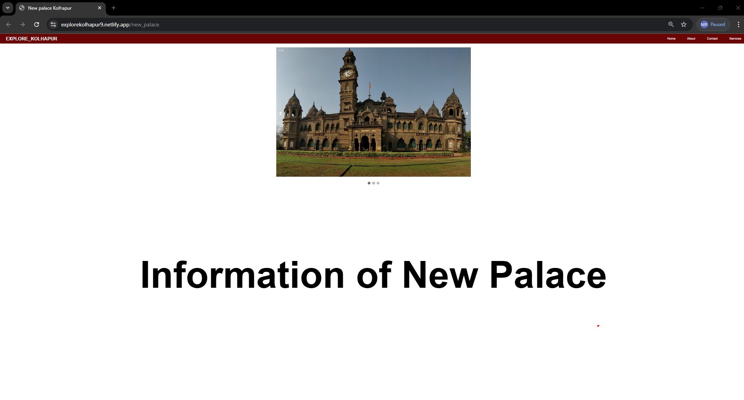

**FIG: -8**

**Future Scope**

The future vision for the Explore Kolhapur website includes enabling users to plan their treks more effectively by offering precise and up-to-date information. Additionally, the platform aims to integrate real-time weather updates for specific destinations. A mobile app is also in development, which will feature offline maps, emergency contact details, and trail information to enhance the trekking experience.

**Objectives**

1)To provide proper and real information of user demand place.

2)To develop the dynamic website.

3)To find efficient root for visiting destination.

4)To suggest nearby places.

5)To provide google map.

6)To develop responsive website.

7)To search the places.

**Working and Methodology**

1)Search for Explore Kolhapur.

2)When you enter the website, you can see search bar to find your favourite place.

3)After search, you can see the image of that place.

4)Then scroll up to see the history about the place, as well as google map. Why place is famous for, nearby spots, hotels, residency to visit.

5)After that you see facilities available on that place and their fees. e.g. rope way, scuba diving etc.

**1. Project Overview:**

Define the purpose and objectives of the traveling blog website.

Specify the target audience (e.g., tourists, travelers, adventure enthusiasts).

Highlight the key features (search functionality, detailed information, booking links).

**2. Technology Stack:**

Choose appropriate technologies for front-end (HTML, CSS, JavaScript), back-end (Node.js, Django, Flask), and database (MongoDB, MySQL, PostgreSQL).

**3. Database Design:**

Identify the necessary data entities (destinations, hotels, images, hidden places, etc.).

**4. User Authentication:**

Implement a user authentication system for personalized experiences.

**5. Search Functionality:**

Develop a search feature allowing users to search for destinations.

Implement filters for refining search results (e.g., by location, popularity).

**6. Destination Page:**

Display detailed information about each destination, including:

High-quality images.

Map with points of interest.

Nearby hotels and accommodations.

**7. Hidden Places Section:**

Create a dedicated section highlighting hidden or less-known places to visit.

Provide descriptions, images, and directions for these hidden gems.

**8. Traveling Facilities:**

Offer information on transportation options (flights, buses, trains) to the destination.

Include details about local transportation within the destination.

**9. Booking Integration:**

Integrate links to external booking platforms for hotels.

Ensure seamless transitions for users to book accommodations directly.

**10. User Interaction and Engagement:**

Implement features for users to leave reviews and ratings.

Allow users to share their own travel experiences and tips.

**11. Responsive Design:**

Ensure the website is accessible and user-friendly across various devices (desktop, tablet, mobile).

**12. Feedback and Iteration:**

Collect user feedback and analytics.

Iterate on the website based on user suggestions and emerging trends.

**Advantages: -**

1)In the website, user can get accurate information about places.

2)User can find nearby hotels and residency at a single website.

3)User can get or know facilities available at the place and their actual cost of facility.

4)User also get actual location of google map at this website.

5)This website is user-friendly**.**

**System Requirements**

**1)Hardware: -**

* Processor: Intel dual core (32 bit)
* RAM: 2GB
* Processor Speed: 2GHz

**2)Software: -**

* Windows 11
* VS code
* Chrome Browser

**Conclusion**

Explore Kolhapur is a comprehensive solution for travellers seeking reliable information and guidance for exploring destinations in Kolhapur. By offering personalized recommendations, detailed information about accommodations, amenities, and transportation, and a user-friendly interface, we empower travellers to plan their trips with confidence and ease. Our commitment to providing accurate and accessible information ensures that travellers can embark on unforgettable adventures throughout Maharashtra. Kolhapur is an under-explored gem in Maharashtra's tourism landscape, with significant potential in religious, cultural, and eco-tourism. While the city is rich in history, culture, and natural beauty, there remain challenges related to infrastructure, marketing, and sustainable tourism practices. However, recent studies and developments indicate a growing awareness of these issues, and future tourism strategies focusing on digital marketing, community involvement, and sustainable practices could help Kolhapur emerge as a prominent tourist destination in the region.

**References**

**1) Kimber, J., Georgievski, M., & Sharda, N. (2006). Developing a Visualization Tool for Tour Planning. International Journal of Tourism Research.**

**2) Pan, B., Maclaurin, T., & Crotts, J. C. (2007). Summarizing urban tourism information from massive blog data. Journal of Travel Research, 46(1), 35–45**

**3) Fesenmaier, D. R., et al. (2009). Understanding the role of information in travel behaviour. Journal of Travel Research.**

**4)Gretzel, U., Fesenmaier, D. R., & Formica, S. (2010). Online tourism information: Understanding user behaviour and preferences. Journal of Travel Research.**

**5) Law, R., et al. (2014). A review of online tourism research: 1998 to 2012. Journal of Travel Research.**